Aldermaston and Woolhampton Benefice News

**(the parishes of Aldermaston & Wasing, Beenham, Brimpton, Midgham and Woolhampton)**

# **Sunday 30th March 2025: Mothering Sunday**

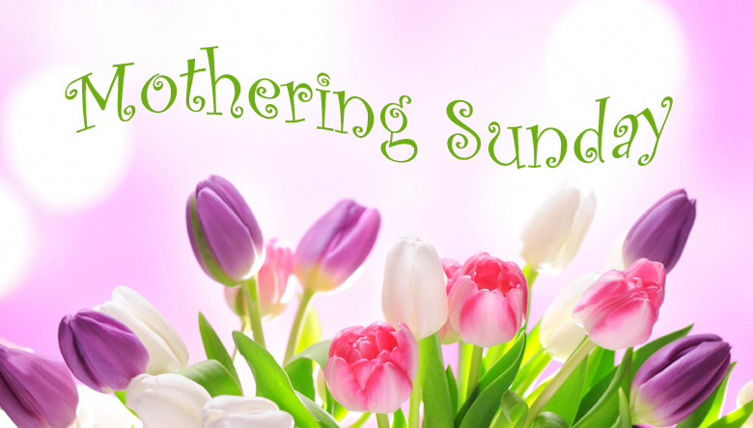

**COLLECT**  God of love, mother and father of all that lives, passionate and strong, tender and caring: watch over us, we pray, and hold us in your arms, all the days of our life; through Jesus Christ our Lord.

**POST COMMUNION PRAYER** Loving God, as a mother feeds her children from her own body, in this sacrament you give us of yourself and feed us with the food and drink of eternal life: help us who have tasted your goodness ever to hunger for you, and to grow in grace within the household of faith; through Jesus Christ our Lord.

**Services this Sunday**

St Mary’s Beenham 10am Benefice Service

**Services on 6th April: Passion Sunday**

St Mary’s, Beenham 9.15am Morning Praise

St Matthew’s, Midgham 9.15am BCP Communion

St Peter’s, Brimpton 10.45am Holy Communion

St Nicholas, Wasing 10.45am Holy Communion

**Benefice Lent Course**

**A Lenten Journey with Paul**

**led by the Revd Dr Derek Spears**

An opportunity to look at different excerpts

from his letters.

The discussion group will be held on the following dates at 2pm

3rd and 10th April

at 1 Church Lane, Brimpton

(each session is independent so you can dip in and out)

For further details please contact the Rector 01189 712 89

**Beenham’s APCM** will be on Thursday 10th April 7.30pm in the church.

**Revision of Electoral Roll** A new electoral roll will be prepared this year. **People on the current roll are not automatically transferred. There** will be forms at the back of each of the churches.

You are entitled to be on the Electoral roll if you are baptised, over 16 and a member of the Church of England or a Church in communion with the Church of England, live in the parish **or** you habitually attend worship (habitually is defined as ‘on average once a month’) Please read the notes on the form. If you have any queries please speak to the Rector or the Electoral Roll Officer.

The deadline for submission for each of the churches is:

Aldermaston & Wasing 25th April

Beenham **18th March – ROLL NOW CLOSED**

Brimpton 13th April

Midgham 28th April

Woolhampton 25th April

**Prayers and Pastoral Care** In the Benefice we seek to offer care for everyone in our churches and our communites, especially when they are in a difficult period in their lives. If you need to talk to a someone or would like a home visit, please contact the Rector on 0118 9712 891

You might just need to talk to someone in complete confidence about a personal or family crisis. We will always listen and help if we can. If you would like prayers included in our services on a Sunday for someone who is ill or in need, (providing the person is aware that they are being prayed for), has recently died or on the anniversary of their death, please do let me know. Revd Jane

We pray for those who are ill at this time and remember those who

have recently died and pray for those who grieve:

Please print this newsletter and hand on to anyone you know who does not have internet access

**Rector:** The Rev’d Jane Manley jmanley.awb@gmail.com

01189712 891

**Assistant Priest**

The Revd Derek Spears [dspears.awb@gmail.com](mailto:dspears.awb@gmail.com)