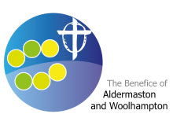Aldermaston and Woolhampton Benefice News

**(the parishes of Aldermaston & Wasing, Beenham, Brimpton, Midgham and Woolhampton)**

# **Sunday 29th June 2025: St Peter**

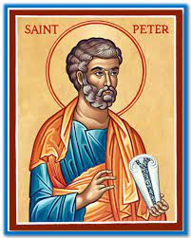

**Services this Sunday**

St Peter’s, Brimpton 9.15am Songs of Praise

St Peter’s, Woolhampton 10.45am Patronal Communion

**Service next week: 6th July 2025**

St Mary’s, Beenham 9.15am Holy Communion

St Peter’s, Brimpton 10.45am Holy Communion

St Matthew’s, Midgham 9.15am BCP Communion

St Nicholas, Wasing 10.45am Holy Communion

**A date for your diary:** On Saturday 4th October 9.30-11am at Aldermaston Parish Hall. The Bishop of Reading, the Rt Revd Mary Gregory, is going to be the guest speaker at a breakfast. All warmly welcome. Details of tickets will be available soon.

.

**Prayers and Pastoral Care** In the Benefice we seek to offer care for everyone in our churches and our communites, especially when they are in a difficult period in their lives. If you need to talk to a someone or would like a home visit, please contact the Rector on 0118 9712 891

You might just need to talk to someone in complete confidence about a personal or family crisis. We will always listen and help if we can. If you would like prayers included in our services on a Sunday for someone who is ill or in need, (providing the person is aware that they are being prayed for), has recently died or on the anniversary of their death, please do let me know. Revd Jane

We pray for those who are ill at this time and remember those who

have recently died and pray for those who grieve:

Please print this newsletter and hand on to anyone you know who does not have internet access

**Rector:** The Rev’d Jane Manley jmanley.awb@gmail.com

01189712 891

**Assistant Priest**

The Revd Derek Spears [dspears.awb@gmail.com](mailto:dspears.awb@gmail.com)