
Aldermaston and Woolhampton Benefice News
(the parishes of Aldermaston & Wasing, Beenham, Brimpton, Midgham and Woolhampton)

Sunday 14th December: The Third Sunday of Advent

COLLECT God for whom we watch and wait, you sent John the Baptist to prepare the way of your Son: give us courage to speak the truth, to hunger for justice, and to suffer for the cause of right, with Jesus Christ our Lord.
FIRST READING Isaiah 35.1‒10
Today’s Gospel refers to this prophecy. Isaiah’s poetry speaks of a world transformed when prisoners are freed, the sick healed, the hungry fed, and all nature bursts with life, as God in person comes to save.
GOSPEL READING Matthew 11.2‒11
The friends of John the Baptist had expected their Messiah to come with political power, but for them and for us the evidence of Christ’s presence is found in our individual lives as he comes constantly to transform us.
POST COMMUNION PRAYER We give you thanks, O Lord, for these heavenly gifts; kindle in us the fire of your Spirit that when your Christ comes again we may shine as lights before his face; who is alive and reigns now and for ever.

Advent Candle Prayer
Lord Jesus, light of the world,
John told the people to prepare,
for you were very near.
As Christmas grows closer day by day,
help us to be ready to welcome you now. Amen.

Services this Sunday
St Mary’s, Aldermaston 10.45am Holy Communion
St Mary’s, Beenham 4pm Carol Service
St Peter’s, Brimpton 6pm Carol Service
St Peter’s, Woolhampton 10.45am Holy Communion
Services on 21st December: The Fourth Sunday of Advent
St Mary’s, Aldermaston 10.45am Holy Communion
St Matthew’s, Midgham 6pm Carol Service
St Peter’s, Woolhampton 4pm Carol SErvice

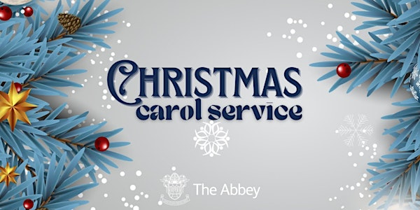

St Nicholas, Wasing 10.45am 7th December
St Mary’s, Beenham 4pm 14th December
St Peter’s, Brimpton 6pm 14th December
St Peter’s, Woolhampton 4pm 21st December
St Matthew’s, Midgham 6pm 21st December

The Revd Katy Weston is unwell at the moment and we pray for her and David. If you have any questions please contact the Rector.


Prayers and Pastoral Care In the Benefice we seek to offer care for everyone in our churches and our communites, especially when they are in a difficult period in their lives. If you need to talk to a someone or would like a home visit, please contact the Rector on 0118 9712 891

We pray for those who are ill at this time

We pray for the Revd Katy Weston

and remember those who
have recently died and pray for those who grieve:

Please print this newsletter and hand on to anyone you know who does not have internet access

Rector: The Rev’d Jane Manley jmanley.awb@gmail.com
01189712 891
Assistant Priest
The Revd Derek Spears dspears.awb@gmail.com

