
Aldermaston and Woolhampton Benefice News
(the parishes of Aldermaston & Wasing, Beenham, Brimpton, Midgham and Woolhampton)

Sunday 30th November 2025: Advent Sunday
COLLECT Almighty God, give us grace to cast away the works of darkness and to put on the armour of light, now in the time of this mortal life, in which your Son Jesus Christ came to us in great humility; that on the last day, when he shall come again in his glorious majesty to judge the living and the dead, we may rise to the life immortal; through him who is alive and reigns with you, in the unity of the Holy Spirit, one God, now and for ever.
FIRST READING Romans 13.11‒14
Isaiah and all Israel expected a new age of the Messiah. For Paul’s readers as for us, the new time has come – not yet in its fullness, but begun in the coming of Jesus Christ. What implications does that have for how we live our lives, day to day?
GOSPEL READING Matthew 24.36‒44
In this new church year, the Gospel on most Sundays will be from that of Matthew. Here, Jesus has some warnings for his disciples about the final coming of the Son of Man. His kingdom will mean a separation between those who are expectant and those left unprepared. God may refuse those who eternally refuse him.
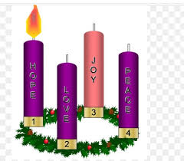
POST COMMUNION PRAYER O Lord our God, make us watchful and keep us faithful as we await the coming of your Son our Lord; that, when he shall appear, he may not find us sleeping in sin but active in his service and joyful in his praise; through Jesus Christ our Lord.

Advent Candle Prayer
Lord Jesus, light of the world,
Bortn in David’s city of Bethlehem,
Born like him to be a king:
Be born in our hearts at Christmas,
Be King in our lives today. Amen.

Services this Sunday
St Mary’s, Beenham 10am Benefice Service
Come and join us at our worship on Sunday when we will be looking at the start of the Advent season through Generosity in Creative Prayer.

Services on 7th December: The Second Sunday of Advent
St Mary’s, Beenham 4pm Christingle Service
St Peter’s, Brimpton 10.45am Holy Communion
St Matthew’s, Midgham 9.15am BCP Communion
St Nicholas, Wasing 10.45am Advent Carol Service

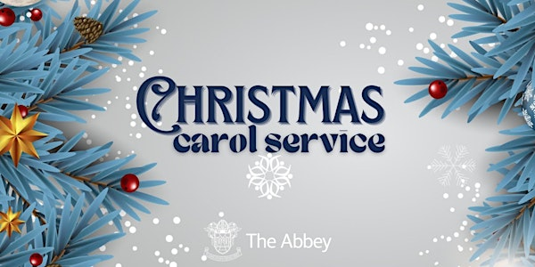

St Nicholas, Wasing 10.45am 7th December
St Mary’s, Beenham 4pm 14th December
St Peter’s, Brimpton 6pm 14th December
St Peter’s, Woolhampton 4pm 21st December
St Matthew’s, Midgham 6pm 21st December

The Revd Katy Weston is unwell at the moment and we pray for her and David. If you have any questions please contact the Rector.

A request for Christmas decorations from Newbury Homeless Shelter
If you have any spare decorations, please could you drop them off at the Rectory and I can take them over. Thank you.

Prayers and Pastoral Care In the Benefice we seek to offer care for everyone in our churches and our communites, especially when they are in a difficult period in their lives. If you need to talk to a someone or would like a home visit, please contact the Rector on 0118 9712 891

We pray for those who are ill at this time

We pray for the Revd Katy Weston

and remember those who
have recently died and pray for those who grieve:

Please print this newsletter and hand on to anyone you know who does not have internet access

Rector: The Rev’d Jane Manley jmanley.awb@gmail.com
01189712 891
Assistant Priest
The Revd Derek Spears dspears.awb@gmail.com

