
Aldermaston and Woolhampton Benefice News
(the parishes of Aldermaston & Wasing, Beenham, Brimpton, Midgham and Woolhampton)

Sunday 23rd November 2025: Christ the King
COLLECT Eternal Father, whose Son Jesus Christ ascended to the throne of heaven that he might rule over all things as Lord and King: keep the Church in the unity of the Spirit and in the bond of peace, and bring the whole created order to worship at his feet; who is alive and reigns with you, in the unity of the Holy Spirit, one God, now and for ever.
FIRST READING Colossians 1.11‒20 Paul wrote this letter to recall the church from divisive ideas to the centrality of Christ in their lives. He breaks into a great song of praise to Jesus, who was before all creation, the image of God on earth, our redeemer, and for ever supreme over all things everywhere.
GOSPEL READING Luke 23.33‒43 On the cross of Jesus, the handwritten sign ‘The King of the Jews’ may have been intended as sarcasm, or mockery, or insult. But Luke knew, as we know, that Christ is indeed the king, and we are citizens of his kingdom.
POST COMMUNION PRAYER Stir up, O Lord, the wills of your faithful people; that they, plenteously bringing forth the fruit of good works, may by you be plenteously rewarded; through Jesus Christ our Lord.

Services this Sunday
St Peter’s, Woolhampton 10.45am Holy Communion
St Matthew’s, Midgham 4pm Sung Evensong

Services on 30th November: Advent Sunday
St Mary’s, Beenham 10am Benefice Service
St Mary’s Aldermaston Afternoon of Bridge on 25th November at Wasing. Details from Rosie Braithwaite Rosie.braithwaite@outlook.com
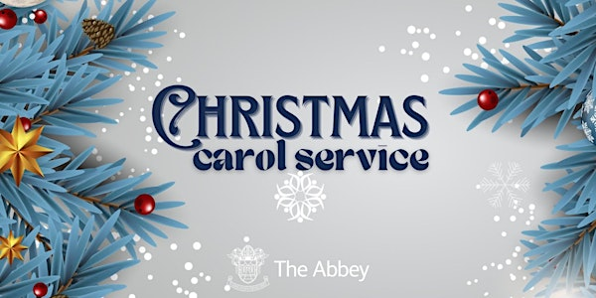

St Nicholas, Wasing 10.45am 7th December
St Mary’s, Beenham 4pm 14th December
St Peter’s, Brimpton 6pm 14th December
St Peter’s, Woolhampton 4pm 21st December
St Matthew’s, Midgham 6pm 21st December

Prayers and Pastoral Care In the Benefice we seek to offer care for everyone in our churches and our communites, especially when they are in a difficult period in their lives. If you need to talk to a someone or would like a home visit, please contact the Rector on 0118 9712 891

We pray for those who are ill at this time and remember those who
have recently died and pray for those who grieve: Sue Rudling (Brimpton)

Please print this newsletter and hand on to anyone you know who does not have internet access

Rector: The Rev’d Jane Manley jmanley.awb@gmail.com
01189712 891
Assistant Priest
The Revd Derek Spears dspears.awb@gmail.com

