
Aldermaston and Woolhampton Benefice News
(the parishes of Aldermaston & Wasing, Beenham, Brimpton, Midgham and Woolhampton)

Sunday 2nd November 2025: The Feast of All Saints

COLLECT God of glory, touch our lips with the fire of your Spirit, that we with all creation may rejoice to sing your praise; through Jesus Christ our Lord.
FIRST READING Ephesians 1.11–23
Paul, writes of the powers of heaven. Now, he says, the risen and ascended Christ is enthroned above all things, and we his holy ones have both the knowledge of his sustaining power here and the hope of glory with him hereafter.
GOSPEL READING Luke 6.20–31
Jesus reverses many of the world’s standards. God does not bless those who are satisfied with themselves, but those who know their need of him and show his love to everyone.
POST COMMUNION PRAYER God, the source of all holiness and giver of all good things: may we who have shared at this table as strangers and pilgrims here on earth be welcomed with all your saints to the heavenly feast on the day of your kingdom; through Jesus Christ our Lord.

Services this Sunday
St Mary’s, Beenham 9.15am Holy Communion
St Peter’s, Brimpton 9.15am Holy Communion
St Matthew’s, Midgham 9.15am BCP Communion
St Nicholas, Wasing 10.45am Holy Communion with
Blessing of Marriage
St Peter’s, Woolhampton 4pm All Souls’ Service

Services on 9th November: Remembrance Sunday
St Peter’s, Brimpton 9.15am Said Communion
There will be a Remembrance Service at 10.45am at Aldermaston, Beenham, Midgham and Woolhampton

Tuesday 11th November 10.50am Remembrance Day: There is a service at St Peter’s, Brimpton War Memorial


Prayers and Pastoral Care In the Benefice we seek to offer care for everyone in our churches and our communites, especially when they are in a difficult period in their lives. If you need to talk to a someone or would like a home visit, please contact the Rector on 0118 9712 891
We pray for those who are ill at this time and remember those who
have recently died and pray for those who grieve:

Please print this newsletter and hand on to anyone you know who does not have internet access

Rector: The Rev’d Jane Manley jmanley.awb@gmail.com
01189712 891
Assistant Priest
The Revd Derek Spears dspears.awb@gmail.com

Afternoon of Bridge with delicious Tea
Tuesday 25th November at Wasing Estate
Wasing Lane, Aldermaston RG7 4NG
By kind permission of Joshua and Di Dugdale
2pm -5pm
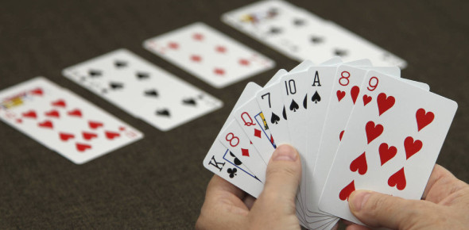
Please follow signs to the Carpark
Bring your own bridge cloth, playing cards and pencils – tables and score cards are supplied
Proceeds in Aid of the work and mission of St Mary the Virgin, Aldermaston
Cost £20 per player
Aldermaston & Wasing PCC
Sort Code 20-05-00
Account 60048437
Ref: Bridge and Surname
RSVP
Rosie.braithwaite@outlook.com
Name and no of players

