Aldermaston and Woolhampton Benefice
Serving the parishes of Aldermaston & Wasing, Beenham, Brimpton, Midgham and Woolhampton

The Pew News
November 2024
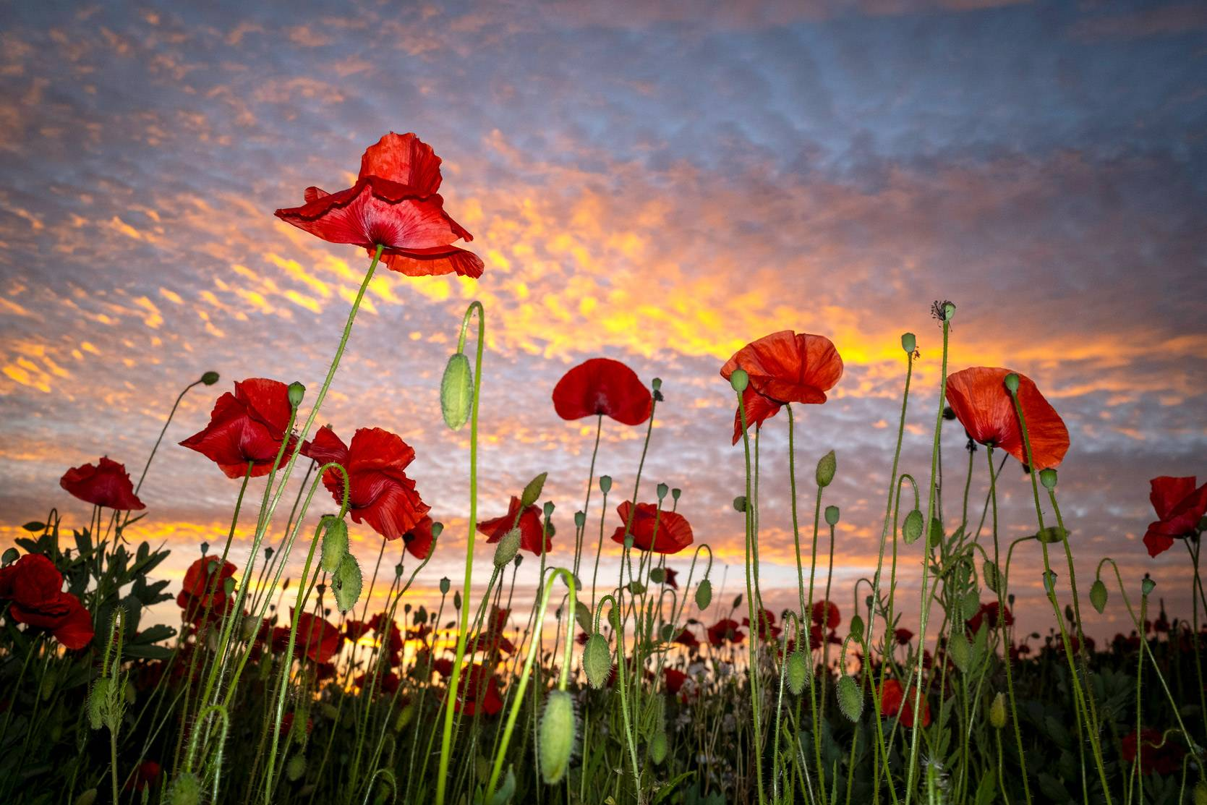

Services in November 2024 across the Benefice
Sunday 3rd November: All Saints’
St Mary’s, Beenham 9.15am Morning Praise
St Peter’s, Brimpton 10.45am Morning Praise
St Matthew’s, Midgham 9.15am BCP Communion
St Nicholas, Wasing 10.45am Holy Communion
St Mary’s, Aldermaston 4pm All Souls’ Service
Sunday 10th November: Remembrance Sunday
St Mary’s, Aldermaston 10.50am Remembrance Service
St Mary’s, Beenham 10.50am Remembrance Service
St Peter’s, Brimpton 9.15am Holy Communion
St Matthew’s, Midgham 10.50am Remembrance Service
St Peter’s, Woolhampton 10.50am Remembrance Service

Monday 11th November: Remembrance Day
St Peter’s Brimpton
(War Memorial) 10.50am Remembrance Service

Sunday 17th November: The Second Sunday before Advent
St Mary’s, Aldermaston 10.45am Holy Communion
St Peter’s, Woolhampton 10.45am Holy Communion
Sunday 24th November: Christ the King
St Mary’s, Beenham 9.15am Holy Communion
St Peter’s, Brimpton 10.45am Holy Communion
St Matthew’s, Midgham 4pm Sung Evensong
St Peter’s, Woolhampton 10.45am Holy Communion

For further details contact: The Rev’d Jane Manley 01189 712 891
jmanley.awb@gmail.com

Remembrance Sunday
Sunday 10th November, 10.50am
Services of Remembrance
across the Benefice
in Aldermaston, Beenham, Midgham and Woolhampton
There will be a service at 10.50am at Brimpton War Memorial on Monday 11th November
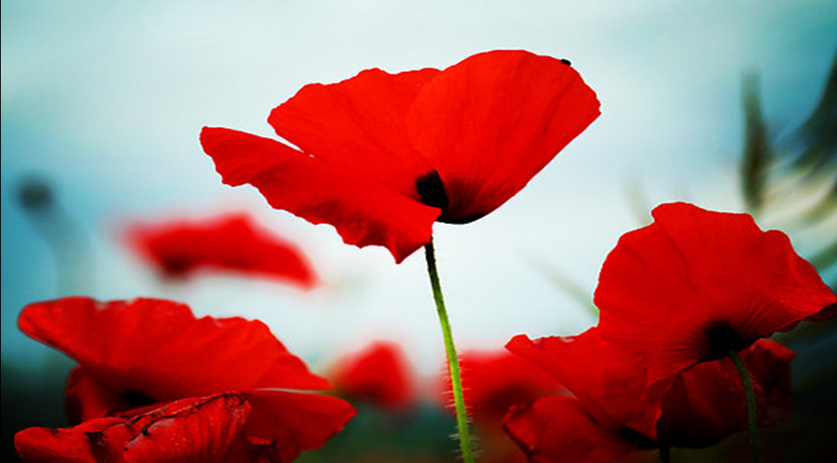

They shall grow not old as we that are left grow old;
Age shall not weary them, nor the years condemn.
At the going down of the sun and in the morning
We will remember them.
Christmas at St Nicholas Wasing
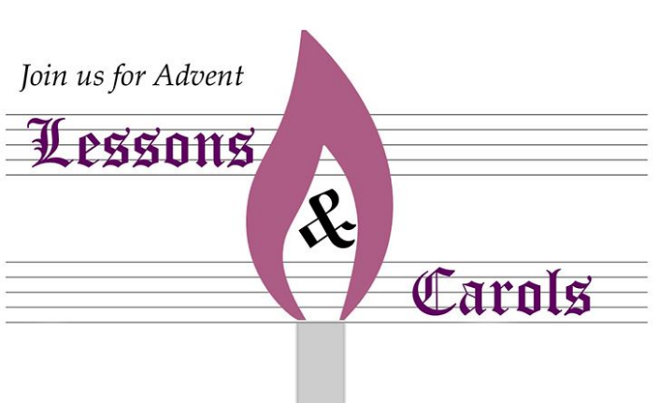
You are invited to a Carol Service
on Sunday 1st December at 10.45am
at St Nicholas Church, Wasing.
This will be followed by pumpkin soup
and Christmas nibbles
in the Garden Room, Wasing.

Please invite your families to this wonderful start
of the Advent season.

To help with catering, please let us know if you are able to attend

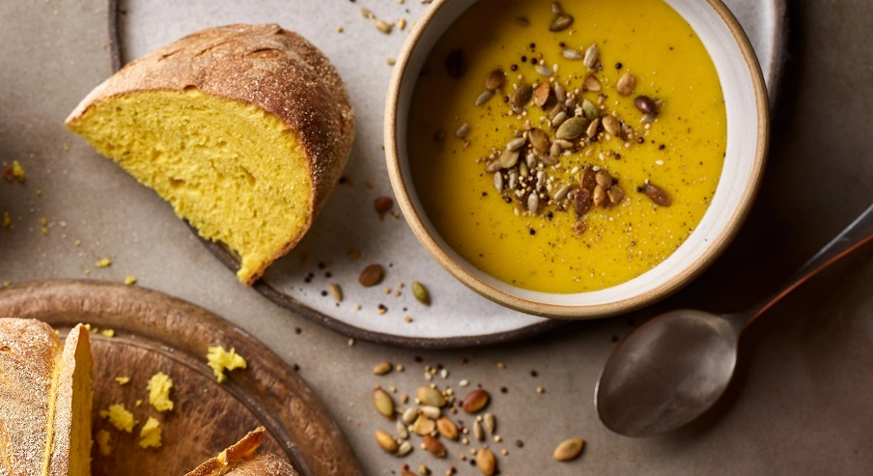
RSVP
Revd Jane Manley
jmanley.awb@gmail.com

Readings for November 2024


 | New Testament | Gospel | Colour
3rd November  All Saints’ Day | Revelation 21.1-6a | John 11.32-44 | White
10th November  Remembrance Day | Hebrews 9.24-end | Mark 1.14-20 | Red
17th November  2nd Sunday before Advent | Hebrews 10.11-14, 19-25 | Mark 13.1-8 | Red
24th November  Christ the King | Revelation 1.4b-8 | John 10.33-37 | Red

Occasional Offices in the Benefice
during September and October
Baptisms
‘Today God has touched you with his love and given you a place among his people’
1st September Rupert and Charlotte Smith, twins of Emma and Wayne Smith at St Nicholas, Wasing
4th September Polly Weaving, daughter of Emily and Alex Weaving at St Nicholas, Wasing
22nd September Niamh Morgan, daughter of Antonia and Lewis Morgan at St Mary’s, Beenham
28th September Layla Rapley, daughter of James and Angela Rapley at St Matthew’s, Midgham
Weddings
‘And now faith, hope, and love abide, these three: and the greatest of these is love’
5th September Dean Procter and Katherine McLaren at St Nicholas, Wasing
8th September Martin Joel and Larissa Borrodell-Brown at St Nicholas, Wasing
14th September Daniel Keates and Naomi Holborough at St Nicholas, Wasing
19th September James Ball and Rhianna Head at St Nicholas, Wasing
12th October Daryl Reis-Day and Charlotte Harland at St Mary the Virgin, Aldermaston
12th October Michael Parks and Emily Chissell at St Nicholas, Wasing
24th October Nathan Rawlings and Charlotte Ellis at St Nicholas, Wasing
26th October Simon Beaney and Jessica Owen at St Nicholas, Wasing
Funerals and Burial of Ashes
‘I am the resurrection and the life,’ says the Lord.
4th September Memorial Service and Burial of Ashes of Gladys Brook at St Mary’s, Beenham
12th September Funeral and Burial of Hilda Erwin at St Mary the Virgin, Aldermaston
4th October Funeral and Burial of Dennis Greetham at St Mary’s, Beenham

All Souls’ Memorial Service
At St Mary the Virgin, Aldermaston
Sunday 3rd November at 4pm
Followed by tea and cake


A time to remember those we love who are with us no longer.

What’s on in our parishes
Beenham
ADVENT CHRISTINGLE SERVICE
Sunday 1st December 2024 at 4pm
St Mary’s Church, Beenham

We look forward to welcoming everyone.
This will be followed by
the lighting of the Christmas Tree at 5pm

Brimpton

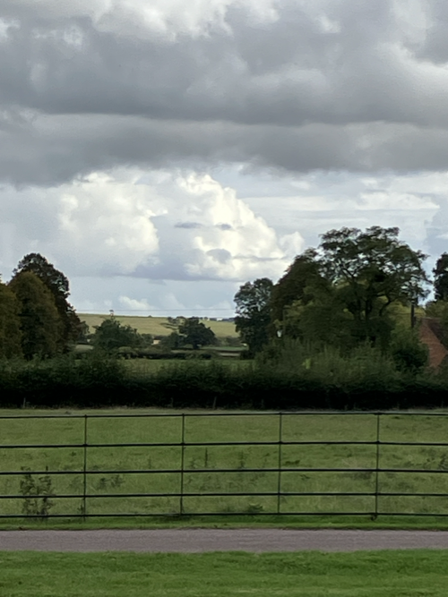
'A cloud, seen over Hanbury Hall, trying to blow the rain clouds away. It did not succeed'.

COFFEE MORNING
(SECOND WEDNESDAY OF THE MONTH)

DROP IN ANY TIME BETWEEN
10:00 am-11:30 am

13th November (Bring and buy)
11th December
8th January 2025

Everyone (including dogs) welcome

COFFEE MORNING and
Christmas themed
Bring-and Buy
Brimpton Church
Wednesday, 13th November
10 am – 11.30 am


All welcome.


Woolhampton
St Peter’s Church Woolhampton

Stella Nesbit has overseen the arranging of flowers in St Peter’s Church for over 60 years and has decided that the time has come to do less. We would like to say a very public thank you to Stella for making the church look so wonderful over quite so many years.

It is important to keep the tradition of flower arrangements going so that our wonderful parish church looks at its best for all of us. Our visitors, our schools and our community.

Would you be prepared to help us by doing the occasional flower arrangement by the altar? Perhaps you might like to do one on an anniversary in memory of someone special (which would be acknowledge during the Sunday Service). If you aren’t familiar with our church but enjoy flower arranging, we would love to hear from you.
If you would rather not do a vase but would like to be involved in preparing the church for Christmas, Easter, Mothering Sunday or Harvest Festival when we come together as a group to make the church look as festive as we can, we would be delighted if you would like to join us.

Please contact Kate Moir on kate@ferrises.co.uk or 07767 823 954 if you would like to know more or become involved.

Midgham
Midgham Café Church
First Thursday of the month

Join us for tea and cake and fellowship 2.00pm
Contact Sarah Henderson for more information
henderson.sarah.c@outlook.com

Our Church Schools

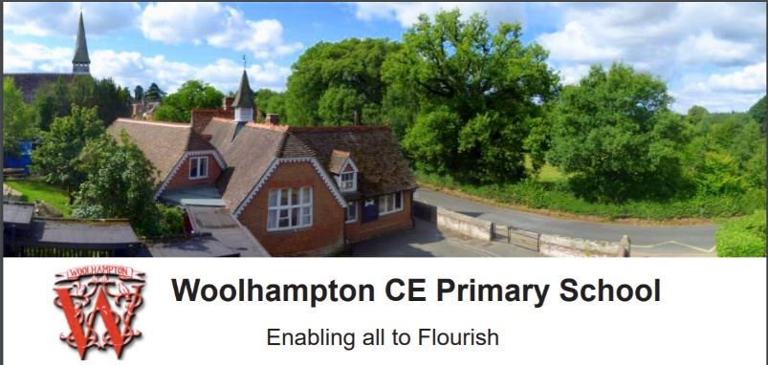

It is hard believe that this year’s intake of children into Beech Class (Foundation), have
only been in the school for six weeks. I watched them take part in Collective Worship today,
and I was incredibly proud to see how they had adjusted to school life, and how attentive
and well behaved they all were.
Beech Class do a great deal of their learning outside the classroom, taking advantage of our
outdoor space, where they have a variety of different areas dedicated to maths, art, music,
writing, construction, science and more. Our team of brilliant teaching staff are always
looking at ways to enhance this area and provide new and varied challenges for the children
(and replace items damaged by this endless rain). They have provided a list that would
greatly help in this and I wonder whether anyone has any of the following things, in relatively
good condition, that they would be happy to donate to the school?
• Musical Instruments (e.g.) maracas, bells, tambourines, drums, gongs, chimes,
triangles etc.
- Buckets, spades, a small wheelbarrow.
- Gravel/stones to fill our construction area.
- Large chalkboards.
- Outdoor easel, paintbrushes large and small.
- Tarpaulin, camouflage netting for dens.
- Planks, cable reels, tyres, guttering, plastic pipes.
- Large plant pots, compost.

If you think you might be able to help, we would be very grateful. Please do contact the
school by email at office@woolhamptonschool.org to arrange drop off, or we can arrange a
pickup if this is easier for you.
Kate Moir
Foundation Governor

 | WEST BERKS FOODBANK

WHEN PEOPLE ARE GOING WITHOUT….

IT IS TIME TO GUARANTEE THEIR ESSENTIALS

WHEN PEOPLE ARE GOING WITHOUT….

IT IS TIME TO GUARANTEE THEIR ESSENTIALS

HELPING LOCAL PEOPLE IN CRISIS

Over 90% of the food distributed by foodbanks in The Trussell Trust network is donated by

the public – that’s why your food donations are absolutely vital to their ability to give

everyone referred to them a balanced and nutritious three-day supply of food.

The shopping list below the food items that are needed right now.

Drop off food donations points are listed below.

Food items urgently needed

Lunchbox individual fruit juice, wet wipes, shaving foam, tinned vegetables, variety pack

cereal, tinned tomatoes/passata, tin meat meals – curry, hotpot, pies etc.

Low on stock

Tinned fruit, honey, custard/rice pudding, long life sponge puddings, tinned soup, size 4 and

8 nappies.

Drop off locations:

Aldermaston and Wasing: The Rectory, Wasing Lane and 19 Swan Drive, The Wharf.

Beenham: Under community noticeboard.

Brimpton: Inside the porch at St Peter’s Church and Georgina Hairdressers.

Midgham: St Matthew’s Church. Open daily between 09:00-15:00.

Woolhampton: Inside the porch at St Peter’s Church.
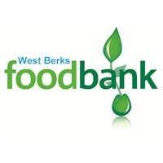

If you are in need, the foodbank is running 7 day food parcels

delivered to you. Call 01635 760560

Butterfly Conservation Upper Thames Branch Churchyard Survey 2024
It is time to report on the butterfly surveys of the six churchyards within the Benefice of Aldermaston and Woolhampton on behalf of the Upper Thames Branch of Butterfly Conservation. The aim is to survey each of the churchyards once a month from May to August and, unlike last year when July was missed due to wet weather, all four surveys were completed and – spoiler alert – they don’t make pretty reading.
Five of the Parish Churches have designated areas for wildlife that have been left uncut to encourage
butterflies, invertebrates, and small mammals. The churchyard of St Nicolas Wasing is manicured as it is a popular venue for weddings but, then again, it is surrounded by the wonderful Wasing Estate, so the butterflies are rather spoilt for choice! Once again, at St Mary’s Beenham, a large proportion of the
churchyard and adjacent graveyard has been left unmown with paths being cut to allow access to graves. The harebells that had re-establishing themselves in the churchyard last year have now been joined by knapweed and Devil’s bit scabious, adding deeper blues to the sky blue of the ever-spreading harebells. This is certainly best practice management of a churchyard for the benefit of Nature, and this was borne out by Beenham being the best performer in numbers and species of butterflies recorded in every monthly survey.
The first survey on 27th of May was a bad start as not a single butterfly was recorded from any of the
churchyards. I guess it was a bit late for the orange tips, but it was an ominous omen for the months to
come. The next, on the 25 th of June was definitely a meadow brown day with 38 counted in all six
churchyards, 16 of which came from Beenham. Pat Owen from Beenham was my helper on these surveys – I wonder if she was augmenting the Beenham sightings? Sadly, there were no ringlets recorded in any of the surveys.
During the visits on 19 th of July, meadow browns were still being observed in most churchyards, but
gatekeepers were the most prominent butterfly, with whites (large, small and green-veined) accompanied by a few red admirals and a solitary comma and brimstone. Again, no ringlets. Appropriately enough, the brimstone was spotted in Brimpton! It may be that the brimstone is responsible for the name “butterfly” as it was once known as the “butter–coloured fly”. We squeezed the last survey in on 26 th of August. With the temperature just breaking 20C and a stiff breeze, numbers were down. Beenham produced meadow browns, whites and a speckled wood, whereas Brimpton and Wasing drew blanks. A single holly blue was spotted at Midgham and this seems to have confirmed my prediction in last year’s report that numbers might decline after last year’s success for this species as the parasitic wasp that preys on it will have grown in numbers and the natural cyclical fluctuation has kicked in. Let’s hope this doesn’t continue going forward.
This noticeable decline in numbers across the board replicates the concerning results of this year’s “Big Butterfly Count” sponsored by Butterfly Conservation. Over 143,000 15–minute recordings were made by 85,000 “Citizen Scientists” between 12 th July and 4 th August, and this has been the worst year in the 14 years of this project with the lowest average of sightings per count. Butterfly Conservation has declared a “Nature Emergency” and is now calling on the Government to impose a total ban on neonicotinoid pesticide use. If you want to sign this petition, please go to https://butterfly-conservation.org/emergency.
Finally, at this time of year, ivy flowers provide much-needed Autumn nectar for butterflies and other
insects, as well as Winter berries for birds, so please think twice before cutting back this much-maligned climber.
Laurence Harwood, Board Trustee of Butterfly Conservation, https://butterfly-conservation.org/
**********************************************************************************************************

Contact details
Rector
The Rev’d Jane Manley 01189712 891 jmanley.awb@gmail.com
https://aldermaston.hubb.church/

