Aldermaston and Woolhampton Benefice
Serving the parishes of Aldermaston & Wasing, Beenham, Brimpton, Midgham and Woolhampton

The Pew News
July 2024


Services in July 2024 across the Benefice

Sunday 7th July: The Sixth Sunday of Trinity
St Mary’s, Beenham 9.15am Morning Praise
St Peter’s, Brimpton 10.45am Holy Communion
St Matthew’s, Midgham 9.15am BCP Communion
St Nicholas, Wasing 10.45am Holy Communion
Sunday 14th July: The Seventh Sunday of Trinity
St Mary’s, Aldermaston 10.45am Holy Communion
St Mary’s, Beenham 9.15am Holy Communion
St Peter’s, Woolhampton 10.45am Holy Communion

Sunday 21st July: The Eighth Sunday of Trinity
St Mary’s, Aldermaston 10.45am Morning Praise
St Peter’s, Brimpton 9.15am Morning Praise
St Matthew’s, Midgham 10.45am Informal Communion
St Peter’s, Woolhampton 10.45am Holy Communion
Sunday: 28th July: The Ninth Sunday of Trinity
St Mary’s Beenham 9.15am Holy Communion
St Peter’s, Brimpton 9.15am Holy Communion
St Matthew’s, Midgham 5pm Sung Evensong
St Peter’s, Woolhampton 10.45am Holy Communion

For further details contact: The Rev’d Jane Manley 01189 712 891
jmanley.awb@gmail.com

Sunday Readings for July 2024


 | New Testament | Gospel | Colour
7th July  Trinity VI | 2 Corinthians 12.2-10 | Mark 6.1-13 | Green
14th July  Trinity VII | Ephesians 1.3-14 | Mark 6.14-29 | Green
21st July  Trinity VIII | Ephesians 2.11-end | Mark 6.30-34;53-end | Green
28th July  Trinity IX | Ephesians 3.14-end | John 6.1-21 | Green

Occasional Offices in the Benefice
during May and June 2024
Baptisms
‘Today God has touched you with his love and given you a place among his people’
2nd June Freddie Knight-Farmer, son of Matthew Knight and Nicole Farmer at St Mary’s, Beenham

Weddings
‘And now faith, hope, and love abide, these three: and the greatest of these is love’
23rd May Kurt Wilson-Luck and Abigail Birch at St Nicholas, Wasing
24th May Curtis Robertson and Stephanie Smith at St Matthew’s, Midgham
28th May Daniel Manning and Emily Harrison at St Nicholas, Wasing
1st June Blessing of James Heward and Megan Ward at St Peter’s, Woolhampton
1st June Angue Millen and Alice Wallwark at St Nicolas, Wasing
22nd June Arron Gorman and Utopia Adaway at St Mary’s, Beenham
22nd June Jamie Allen and Polly Stockton at St Nicholas, Wasing

Funerals and Burial of Ashes
‘I am the resurrection and the life,’ says the Lord.
21st May Burial of Ashes of David Humphreys at St Mary’s Aldermaston
22nd May Funeral of Susan Storey at St Peter’s, Brimpton
12th June Burial of Ashes of John Smalley at St Mary’s, Aldermaston
15th June Memorial Service for Jennifer Lucas-Carter at St Mary’s, Aldermaston
18th June Funeral and burial of Margaret Hinder at St Mary’s, Beenham

What’s on in our parishes
Aldermaston & Wasing
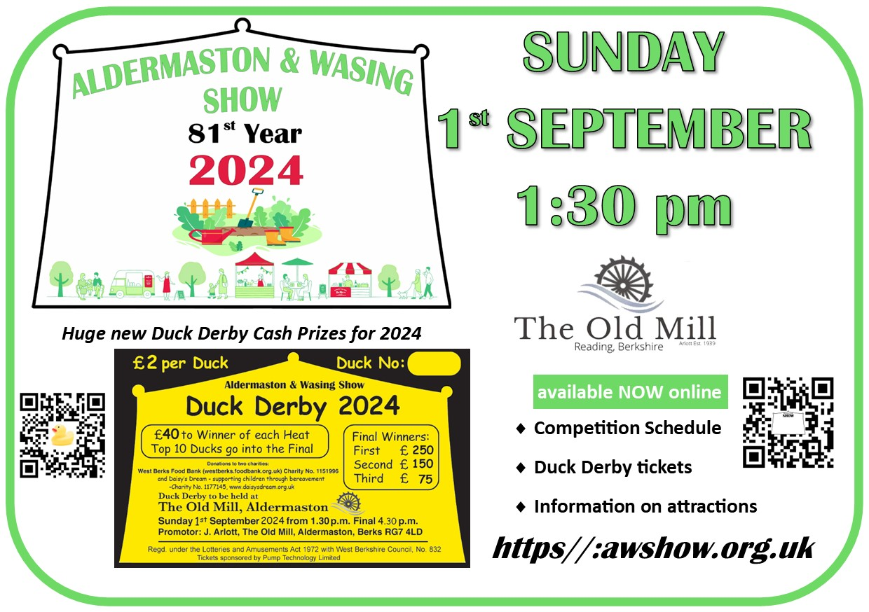

Beenham
St Mary’s Church, Beenham invites you to a

of solos, duets and trios from the Musicals,
ranging from sultry to scintillating,
performed by
Belle Canto Trio
6.00 pm on Sunday 30th June 2024
St Mary’s Church, Beenham RG7 5NN
Tickets at £12.00 include a glass of sparkling wine and canapés
and are available from Janette Hammond
on 07917 818283 or janette@janettehammond.co.uk
or on the door
Proceeds to St Mary’s Church Renovation Project
www.facebook.com/bellecantotrio

Brimpton
The winner of the Brimpton 100 Club in June was no. 87, Jonathan Hunt.

SAVE THE DATE!
BRIMPTON HARVEST FESTIVAL
AND
BARBECUE LUNCH
at Manor Farm, Brimpton

Sunday 29th September

Midgham
Organ Recital given by Gill Blythman
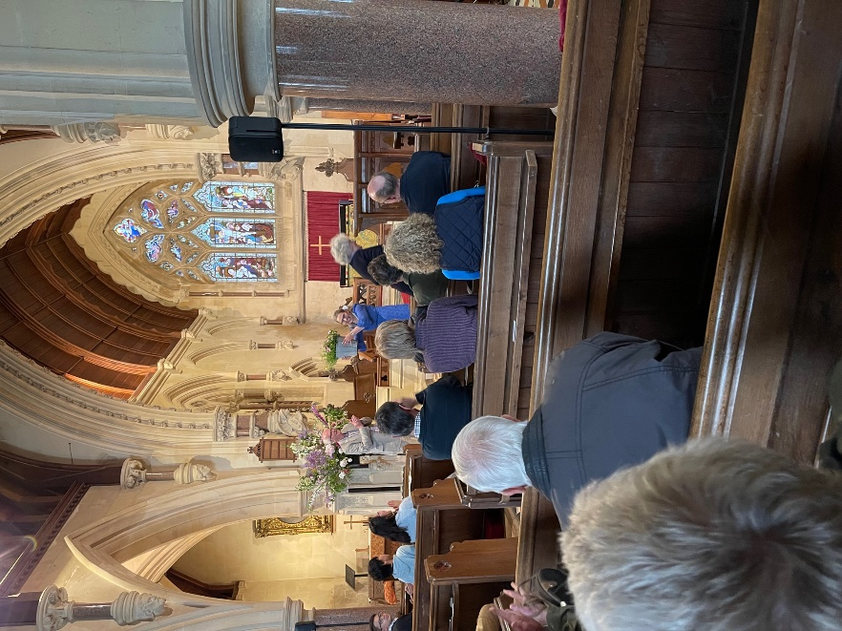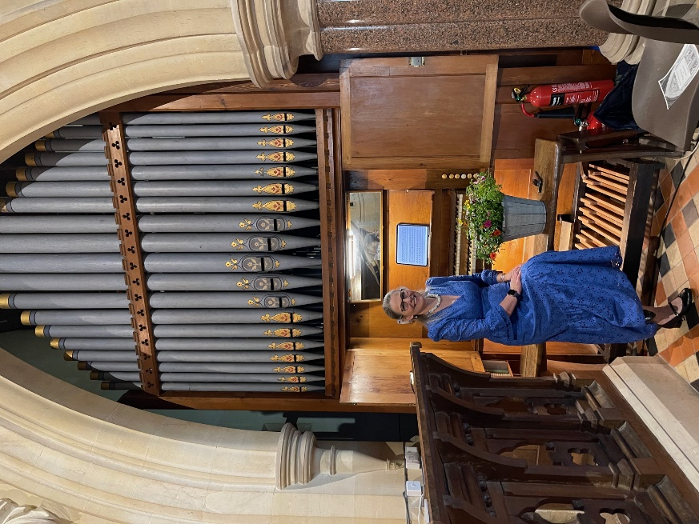
On Saturday 1st June Midgham church hosted an organ recital given by Gill Blythman. Gill gave a wonderful repertoire of music including composers such as Buxtehude,Bach, Mons Leidrin Takle and Matthias Nagal. The evening was well attended and the concert ended with the usual wonderful refreshments of St Matthew’s. Our thanks to Gill and to Richard Foster for organising the event.

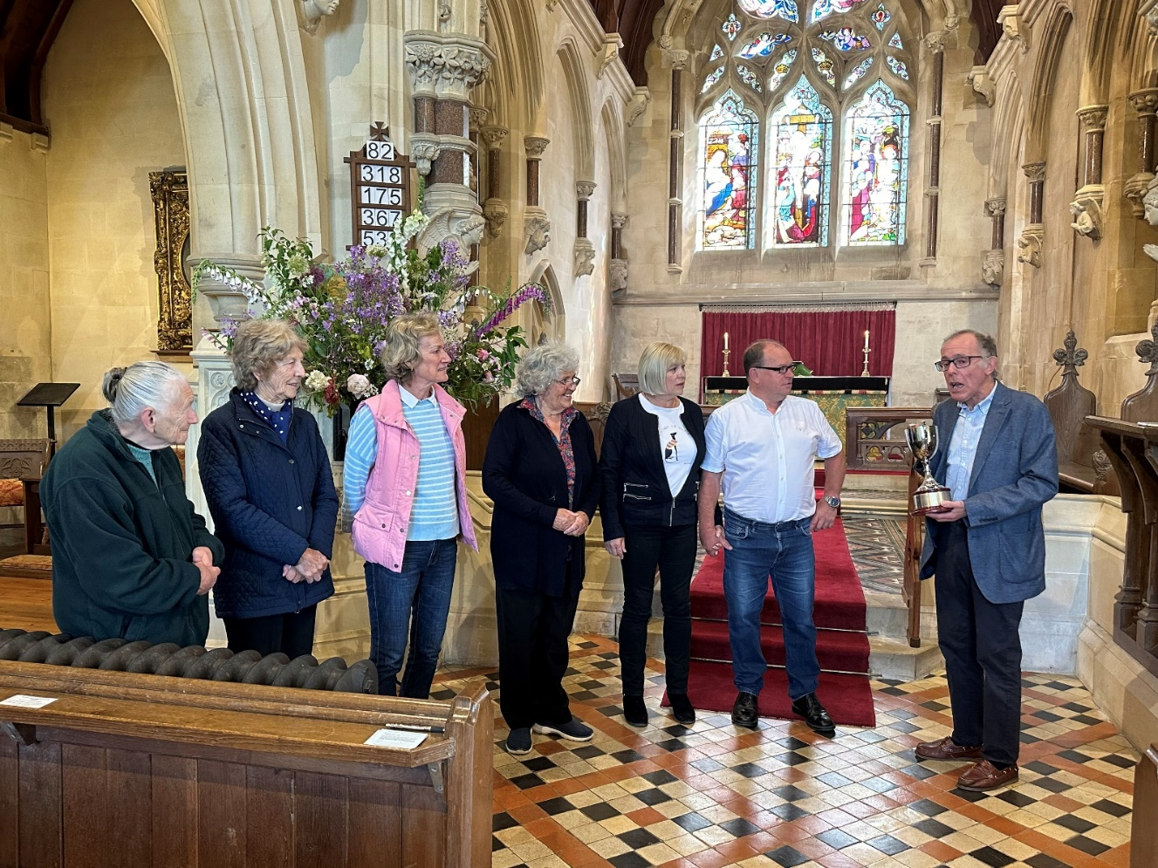
The sterling riders of Midgham being presented with the Ride and Stride cup for 2023 for raising the most money and for their community involvement.


Saturday September 14th
Midgham’s annual Sponsored Ride & Stride event!
Come and join us cycling a well-known route round the beautiful countryside with a stop for lunch!

It is a fun day with a great group of people – if you wish to join us contact Julia for more information.
The sponsorships help keeping St Matthew’s and other local churches open for the community.

julia@emftechnology.co.uk Mobile: 0787 635 2988


Pet Service at Midgham
We held our annual Pet Service on Sunday 16th June in glorious sunshine. It was well attended, including 10 very well behaved dogs.
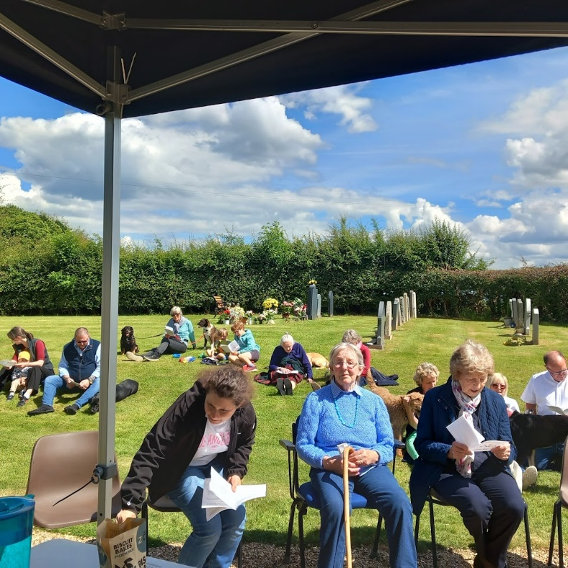

Our Church Schools
ALDERMASTON CE PRIMARY SCHOOL
We welcomed in the Mental Health Support Team into school to work with our Robins class (Years 1 & 2). The session was well timed as children are starting to think about the changes that will happen at the end of this school year. For our Year 2 children, this involves joining Owls Class as Year 3 children and enjoying the new challenges in KS2. For our Year 1 children, it’s being at the top of their class and helping to support the younger children when they join as Year 1s in September. The children talked about what it means to feel anxious or worried and answered the question, ‘What is a worry?’ They were able to talk about how someone might feel if they were worried. The team helped them learn how to make their worries smaller by talking to a trusted adult or using strategies which included breathing exercises. It’s been lovely to see the children’s confidence grow in recognising when they are worried and understanding which zone they are in on their Zones of Regulation chart.
A team of twenty athletes represented our school at the recent Quadkids athletics competition. The conditions were warm and sunny and there was an amazing turnout of children and supporters from schools around the local area. Each child took part in four events: a sprint, middle distance run, vortex javelin and standing long jump. It was an amazing experience and the children’s performances were impressive with many excelling in their favourite events and all taking on the challenge of a proper middle-distance race in very hot conditions.
Please see the advert for our Summer Fete being organised by our PTA. We do hope that you can join us – Fun for the whole family!
Cathy Jones, Foundation Governor




Brimpton Church of England
Primary School
Amazing things happen here…..

Winchester Science Museum

The topic for this term is ‘Space’. The whole school visited the Science Museum to see the planetarium and take part in various workshops associated with space to help the children with their learning

Governor in School Day

Our governing body came into school in early June to observe classroom lessons and to engage with the children and staff to see how a typical day at Brimpton is conducted. They were even brave enough to stay and have their lunch with the children! Our Diocese Adviser came later in the day to talk with staff about our upcoming SIAMS Inspection - Statutory Inspection of Anglican and Methodist Schools

Year 6 Transition

This is always a busy time and an anxious time for our Year 6 children as they start thinking about and preparing themselves for Secondary School. All the schools offer transition days during July and all the Year 6 children will have at least 2-3 days in their new schools to get use to where they will be. Children from our school have extra visits. We are sending children to six different secondary schools this year!

Ice Cream Friday

We have started an ‘Ice Cream Friday’ event whereby each class donate and sell ice creams and lollies for £1 each at the end of the day on a Friday. We are hoping to raise enough money to help pay for a coach to take us to the O2 in January for the Young Voices choir event. If anyone from the village would like to come along at 3pm every Friday and purchase an ice cream or two you are very much welcome. This will continue until Friday 19th July.

If you require any other information regarding Brimpton School
Please contact Mrs Sarah Vockins on 0118-9712311
office@brimpton.w-berks.sch.uk www.brimton.w-berks.sch.uk

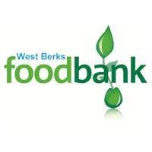
SOS from Foodbank as stocks fall to record low.
The shelves at our warehouse are standing empty as the demand for help regularly outstrips the donations received. In the last 5½ weeks £16,000 from our operating stocks has had to be spent to keep shelves stocked. Last year, WBF supported 14,000 people and the demand this year is growing. This summer, the Hungry Holidays scheme is supporting 1,229 children from 46 schools across Berkshire who need help over the school holidays. We are supporting breakfast clubs at the homeless hostel Two Saints, whose funding has been cut, and at a number of schools – more have approached us for help in establishing one, aimed at families not eligible for free school meals.
PLEASE CAN YOU HELP!
I have attached a copy of the current urgently needed shopping list. Please could you circulate this?
The Mayor of Newbury has chosen WBF as his chosen charity and is holding a coffee morning this Saturday, 22nd June 10am – noon, in the Town Hall. Please let as many people know as possible to come ad support the Foodbank,
We also have a collection promotion at Sainsbury’s in Newbury tomorrow, Friday 21st June and at Waitrose in Newbury on Friday 12th July. Please pass on this message and ask people to consider, if they can, donating an item or two from the attached shopping list whilst doing their weekly shop.Please also remember that all our churches are referrers and so can let us know of anyone who they become aware of who needs help. I have attached a Referrers’ form.

Thank you for your support and remember together we can do it! Sheila

Sheila Moore
Churches Collections Manager
West Berks Foodbank
07778 992862
Email: Churches@westberks.foodbank.org.uk

Urgently Needed
Biscuits
Ketchup
Shampoo, Shower Gel, Deodorant
Tinned Vegetables
Confectionery, Sweets & Treats
Tinned Soup or Cup-a-Soup
Instant Coffee
Cereal or Cereal Bars
Low on Stock
UHT Milk
Long Life Fruit Juice
Squash Drinks
Tinned Fruit
Long Life Sponge Puddings
Tinned Custard or Rice Pudding
Dried Milk or Marvel
Mug Shots or Pot Noodles
Well Stocked NO MORE REQUIRED
Baked Beans, Pasta
Your donations make a BIG difference
to local people in crisis. Thank you
**********************************************************************************************************
Contact details
Rector
The Rev’d Jane Manley 01189712 891
jmanley.awb@gmail.com
https://aldermaston.hubb.church/

